EXERCISE NO:8

REGISTER NO:1518102103

Name:S.PREYATHARSENI

AIM: TO WRITE a python program to get list,sorted in increasing order by the last element in each tuple from given list of non empty tuples.

Program:

def last(n): return n [ -1 ]

def sort_list_last(tuples):

return sorted(tuples, key=last)

print(sort_list_last([(2, 5), (1, 2), (4, 4), (2, 3), (2, 1)]))

link: <http://103.53.53.18/mod/vpl/forms/submissionview.php?id=317&userid=1707>

output:

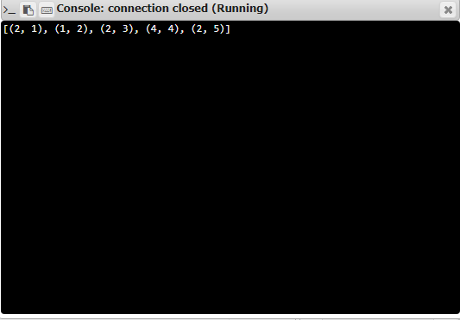

Result:

Thus, the code has been successfully executed and output is verified. ­­­­­